**Reoccurring Invoices**

The reason our clients want reoccurring invoices is because it will automatically bill the customers they set up monthly, annually, etc. This needs to be kept in an organized way and also in a way where you can view which customers need to be charged.

Put “Add New Reoccurring Invoices” in the inventory tab on the side bar under “Add New Device Inventory”

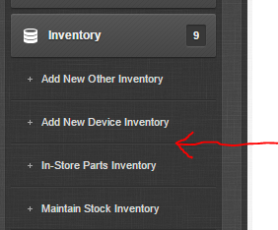

Selecting this will give you three options when making a reoccurring invoice.

* Name
* Price
* Cost

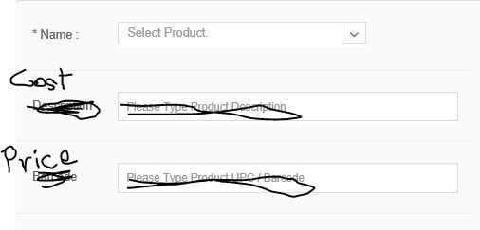

We need a new Tab at POS page. Next to Other Inventory, Device Inventory, and Manually, we can put Reoccurring inventory.

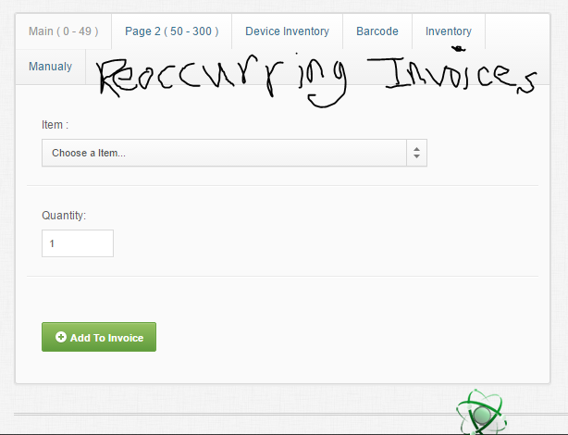

When these reoccurring invoices are clicked on and one of the stock is selected, then it will give more options and descriptions for when the invoice will reoccur. These options will include:

* Frequency (Monthly, Weekly, Biweekly, Quarterly, Semi-Annually, Annually)
* Start Date
* Auto-charge credit card on file. (When we get the authorize.net)
* Email customer the PDF
* Notes on each Reoccurring invoice

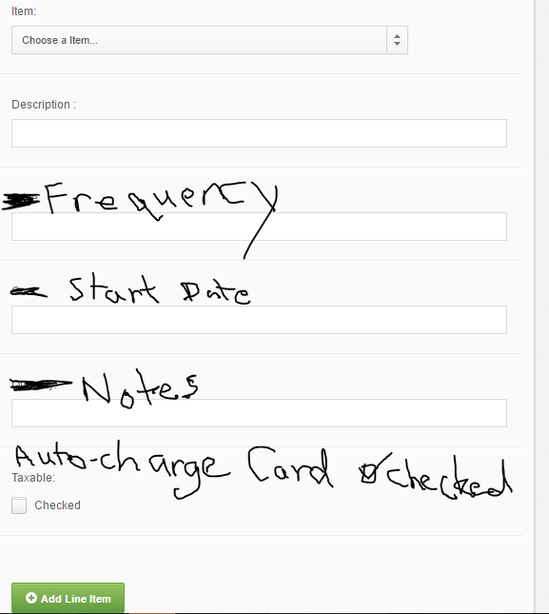

There needs to be a list for the Reoccurring invoices as well. This way the salesman can keep track of them.

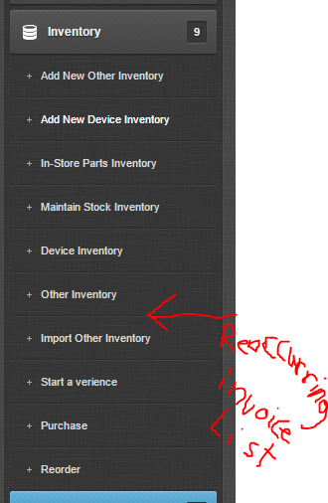

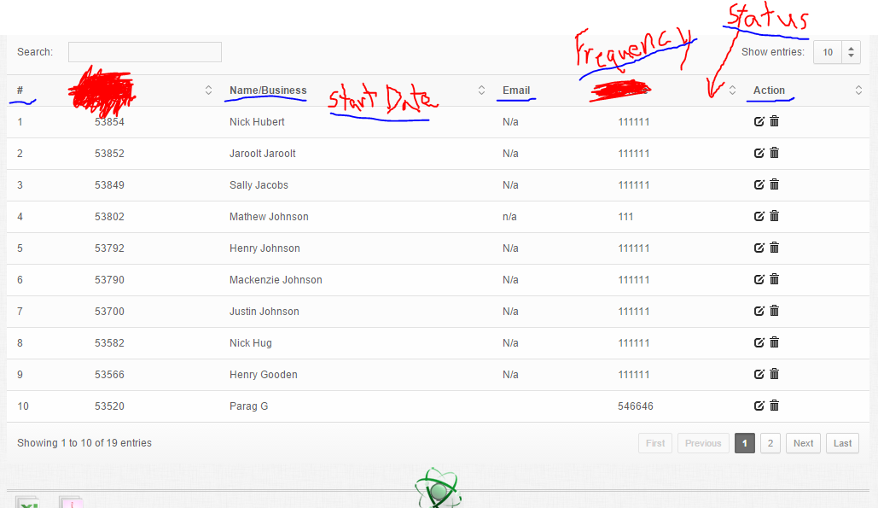

Along with an Edit option that allows you to be able to:

* Pause The Reoccurring Invoice
* Change Frequency
* Change Start Date
* Change customer email
* Change the Notes on Reoccurring invoice
* Change the Credit Card on file (Credit card be ******’ed out)
* Change Price
* Change Status (Active or Cancelled)

